**YEAR 11 GENERAL SCIENCE IN PRACTICE**

**Wheels in Motion**

**TASK 3: Speed Racers PRACTICAL ASSESSMENT (5%)**

This **PRACTICAL ASSESSMENT** will take **50 MINUTES** to complete in class.

**Conditions:**

Students will collect time and distance data, then use this data to perform calculations and display data in a motion graph.

Part A of this task will be completed in groups and Part B will be completed individually.

**Task:**

You will be required to time vehicles as they move along a track. Times will be used to calculate average and instantaneous speeds, and plot speed/time graphs. You will be assessed on your ability to manipulate apparatus, take accurate readings, represent data graphically and work.

You will have completed the following practical activities on the following in class:

* Speed
* Velocity
* Acceleration

**Task weighting: 5%**

**Title: Speed racers**

You will be timing a vehicle as it moves along a track. The vehicle’s time will be measured as it passes through check points to enable you to calculate and graph their average and instantaneous speeds at the various points along the track.

You will have FIVE MINUTES at the start of the lesson to assign a driver and set up various timers at the check points along the track. Practise timing your vehicle as it moves around the track.

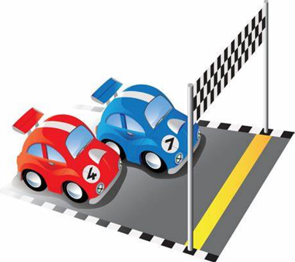Your group will be provided with the following materials:

* Vehicle (e.g. Sphero, wind-up car)
* 4 stopwatches

The teacher will:

* Monitor your ability to manipulate the equipment correctly and safely

**Answer sheet (32 marks)**

* Follow the instructions provided on this task sheet and by your teacher
* All responses should be recorded in the spaces provided
* Your teacher will be monitoring your ability to manipulate the equipment correctly and safely

**Part A: Collecting data – group activity (8 marks)**

Allocate roles to each member of your group and record their names below:

|  |  |
| --- | --- |
| **Role** | **Name of group member** |
| Driver |  |
| Check point 1 |  |
| Check point 2 |  |
| Check point 3 |  |
| Finish line |  |

**Procedure:**

1. Place the vehicle at the start line.
2. When the vehicle starts, each timer should start their stopwatch.
3. As the vehicle passes each check point, the timers at that check point stops their stopwatch.
4. Record the time taken to reach each check point in columns C-E of Table 1 below.
5. Repeat steps 1-3 two more times.
6. Your teacher will provide you with the distances from the start line for each check point and the finish line. Record the distances in column B of Table 1 below.

**Results:**

a) Data recorded in columns B-E in Table 1. (4 marks)

**Table 1**

|  |  |  |  |  |  |  |
| --- | --- | --- | --- | --- | --- | --- |
| **A** | **B** | **C** | **D** | **E** | **F** | **G** |
| **Check point** | **Distance from start line (m)** | **Trial 1 time (s)** | **Trial 2 time (s)** | **Trial 3 time (s)** | **Mean time (s)** | **Speed (m/s)** |
| **1** |  |  |  |  |  |  |
| **2** |  |  |  |  |  |  |
| **3** |  |  |  |  |  |  |
| **Finish line** |  |  |  |  |  |  |

b) Performs allocated role safely and effectively to collect data. (3 marks)

c) Uses standard operating procedures to ensure the safe use of equipment. (1 mark)

**Part B: Processing data – Individual activity (24 marks)**

**Question 1 (12 marks)**

1. Calculate the mean time for each check point. Record your answers in column F of Table 1 in Part A. (3 marks)

b) Draw a distance-time graph to represent your vehicle’s journey during the race. (5 marks)



c) Describe the motion of your vehicle as it travelled along the track. Use data from Table 1 and your graph in your description. (4 marks)

______________________________________________________________________________

______________________________________________________________________________

______________________________________________________________________________

______________________________________________________________________________

______________________________________________________________________________

______________________________________________________________________________

______________________________________________________________________________

______________________________________________________________________________

**Question 2 (12 marks)**

a) Circle the formula you would use to calculate the speed at each check point. (1 mark)

$$speed=\frac{distance}{t} v =\frac{s}{t} a =\frac{v-u}{t}$$

b) Use the formula you selected in 2a) to calculate the speed at each check point. Record your answers in column G of Table 1 in Part A. (3 marks)

c) Calculate the velocity of your vehicle at check point 1. Show all your working. (4 marks)

d) Calculate the acceleration of your vehicle from the start line to check point 1. Show all your working. (4 marks)

**END OF ASSESSMENT 😊**